C.V. and publication list: Chen Dubi, PhD
PERSONAL INFORMATION:
Date of birth: April 1973, born in Israel.
Marital status: Married+3
Email: chendb331@gmail.com
Telephone: 0506-226552
Home address: Atad 40, Beer-Sheva, Israel
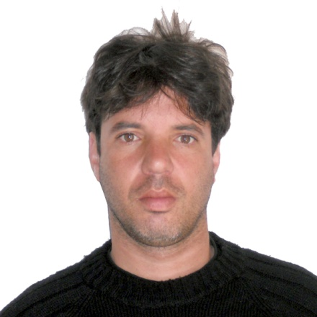

EDUCATION:
2000 - 2004 Dep. of mathematics, Ben Gurion University
PhD student
Thesis title: "Reproducing kernel Hilbert spaces: interpolation, realization and related topics". Under the supervision of Prof. Daniel Alpay.
In my PhD, I have studied the generalization of several topics in control and realization theory from the setting of one to N dimensions.
In particular, I gained results in the following areas:
- Multi dimensional backward shift operators
- Multi dimensional realizations (In particular, those corresponding to the Fornasini-Marchesini model)
- Interpolation and moment problems in multi variable reproducing kernel Hilbert spaces.
The main results of my PhD research were published in a series of 6 journal papers. For my achievements during my PhD studies I was nominated for the "Chlore" prize (nationwide), and was honoured by the Deans award for PhD students (one recipient).

1998- 2000 Dep. of mathematics, Ben Gurion University
MsC student

Thesis title: "Limiting current in electro diffusion". Under the supervision of Prof. Itshak Rubinstein.
In my thesis we have addressed certain ordinary differential equation with singular perturbations arising from electro diffusion processes. In particular, we characterized currents under which neglecting the perturbation coefficient would results in large errors.
The main results of my thesis where published in [6].
Graduation with excellence.

1995-1998 Dep. of mathematics and computer science, Ben Gurion University
BsC student

Specialization in applied mathematics: in particular in differential equations, real and complex analysis, and analytic methods in mathematics.
Graduation with excellence.

PROFESSIONAL EXPERIENCE:
Employment history:
2009-current NRCN ("KAMAG")
Position: research

2008-2009 Ben- Gurion university if the Negev
Position: external lecturer
During the first semester of 2008-2009 academic year, I have taught the following courses at Ben-Gurion university (BGU):
- Partial differential equations.
- Introduction to probability theory.
- Numerical methods in engineering (Dep. Of civil engineering)

2005 – 2008 Shamoon College of Engineering (SCE)
Position: Lecturer
As a lecturer at SCE, most of my courses were given to electrical engineering students. I have also instructed one final project, titled "A new model for deformations in thin rods due to impact" at the software engineering department. The project was in collaboration with MOTOROLA lab. , Tel Aviv.
In my three years at SCE I have maintained a study and active research, resulting in 9 journal papers in the last three years.

Courses I taught include:
- Calculus1 and 2.
- Introduction to differential equations.
- Complex functions.
- Linear Algebra.
- Vector analysis.
- Engineering Mathematics for Electronics.
- Probability and statistics.

2004 – 2005 The Weizmann institute of Science
Post Doctorate Fellow, Dep. Of mathematics
Hosted by Prof. Harry Dym.
During my post doctoral period, I have joint Prof. H. Dym studying correspondence between non-homogeneous Algebraic Riccati equations and de Branges-Rovnyak spaces. The main results of our study were published in [9] and were later presented at the international MTNS2006 conference, Kyoto, Japan.
2004 – 2005 Negev Academic collage of engineering
Teaching assistant (parallel to Post Doctorate Fellow at the Weitzman institute)
Lectures in Calculus 1 and Introduction to statistics and probability.

1998 – 2004 Dep. of mathematics, Ben Gurion University
Teaching assistant (during PhD and MsC)
Lectures in:
- Partial differential equations
- Ordinary differential equations for mathematicians (qualitative theory)
- Ordinary differential equations for engineers (solution techniques)
- Linear Algebra 1 (for Mathematics students)
- Introduction to logics and set theory
- Automata and formal languages.

LIST OF PUBLICATIONS:

Will be submitted on request

GRADUATE STUDENTS:

- Tal Malinevich, MsC student at the Mathematics Dep., Ben Gurion university, Thesis title: "Multi-type time-continuous Markovian branching process in sub-critical systems", finalized 2016.

