**Installation of a License Key**

**using a**

**Product License Code**

Version 1.0

SPECTRO GmbH

Creation Date: 04/17/2014

Last Change Date: 04/17/2014

Table of Contents

1 Preconditions 3

1.1 Information 3

2 Installation of a License Key 4

2.1 Instrument PC with Internet Access 5

2.2 Instrument PC without Internet Access 8

2.2.1 Part 1: On the Instrument Computer 8

2.2.2 Part 2: On a Computer with Internet Access 11

2.2.3 Part 3: On the Instrument Computer 15

3 Remarks 17

3.1 No Internet Access at the Customer Site 17

3.2 Remarks on Product License Codes and License Keys 18

# Preconditions

* The Smart Analyzer Vision Version 6 or higher is installed on the instrument / customer PC.
* Valid **Product License Code** for the software (Smart Analyzer Vision and / or optional module, i.e. Smart Chrom Pro, …)

## Information

A **Product License Code** for the software is printed on a **License Certificate**:



# **Installation of a License Key**

Start the program **License Installation Pro**:

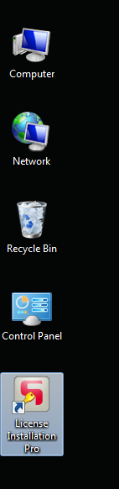

There are two possible setups:

1. Instrument PC with internet access
2. Instrument PC without internet access

## Instrument PC with Internet Access

The welcome screen of the program **License Installation Pro** shows the following display:

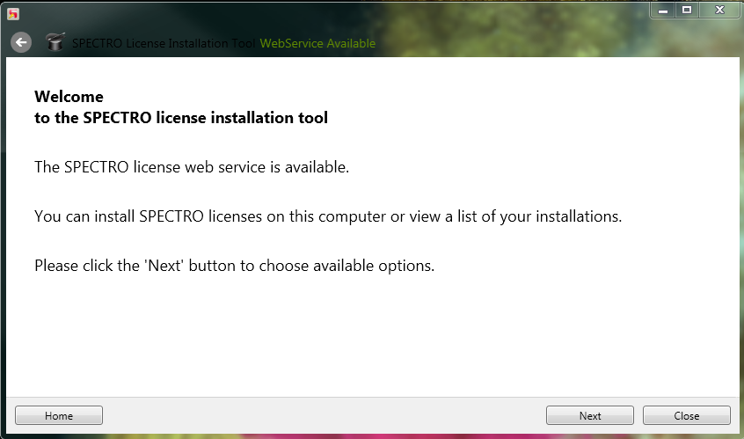

Click **Next**:

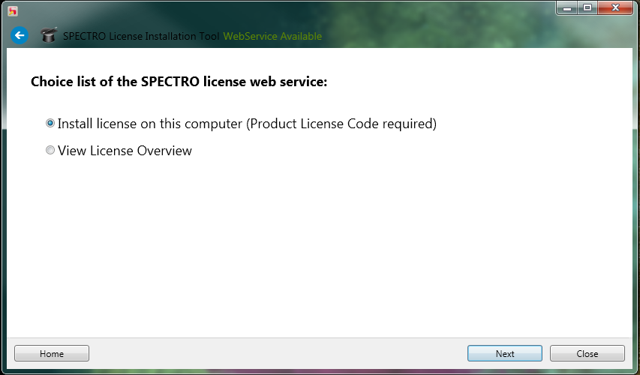

Click **Next**:

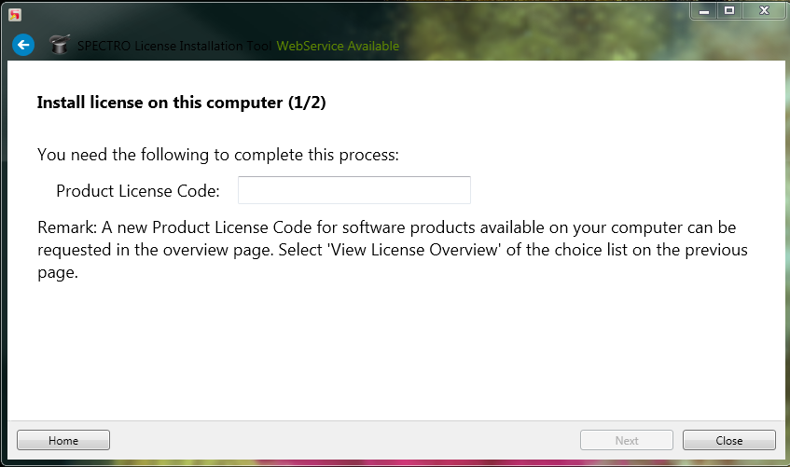

Enter the **Product License Code** as given on the **License Certificate**:

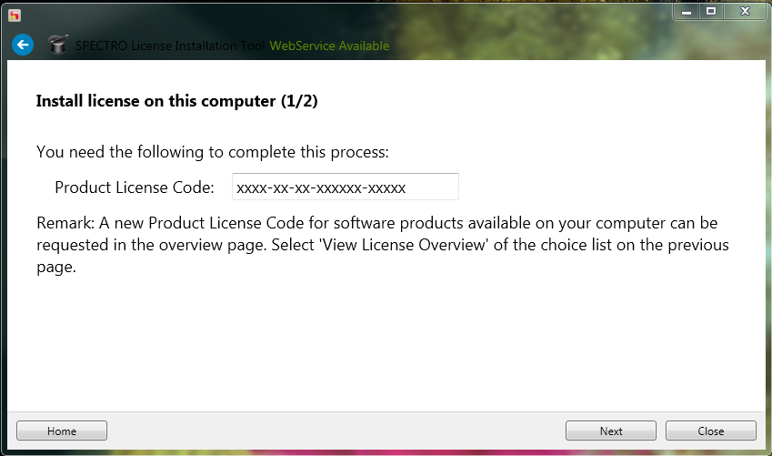

Click **Next**:

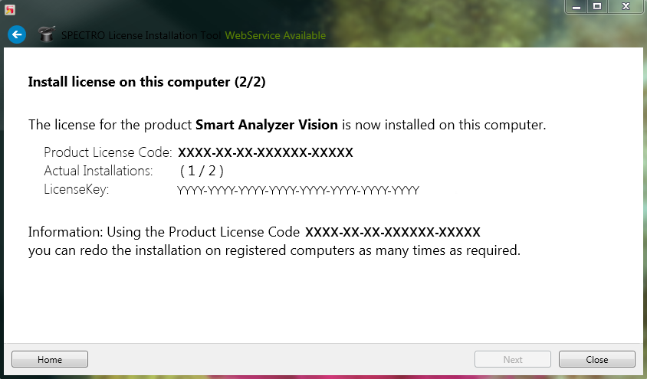

Click **Close.**

The **License Key** is now installed on the computer.

## Instrument PC without Internet Access

### Part 1: On the Instrument Computer

The startup screen of the program **License Installation Pro** shows the following display:

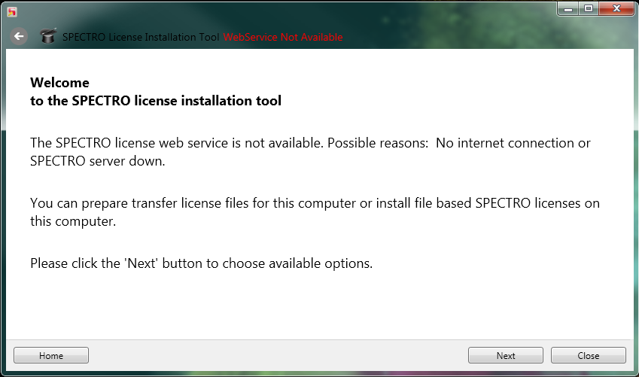

Click **Next**:

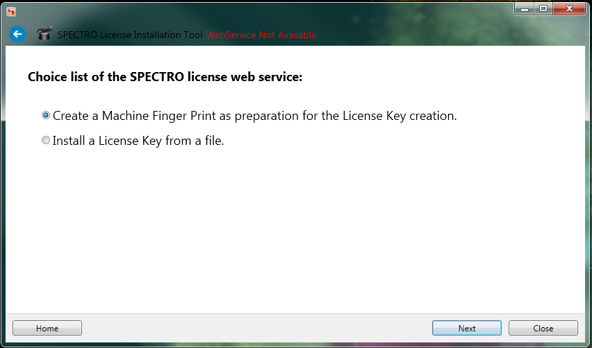

Click **Next**:

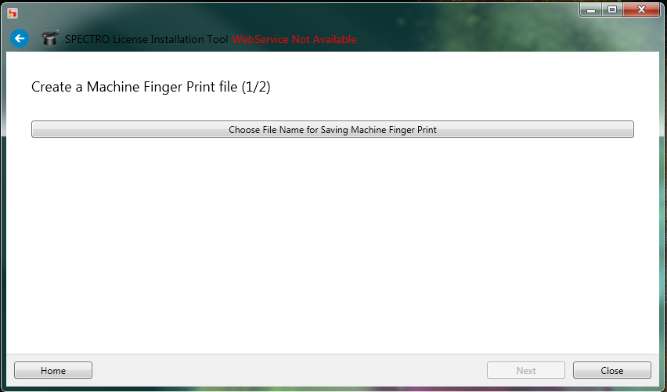

Click **Choose File Name for Saving Machine Finger Print**:

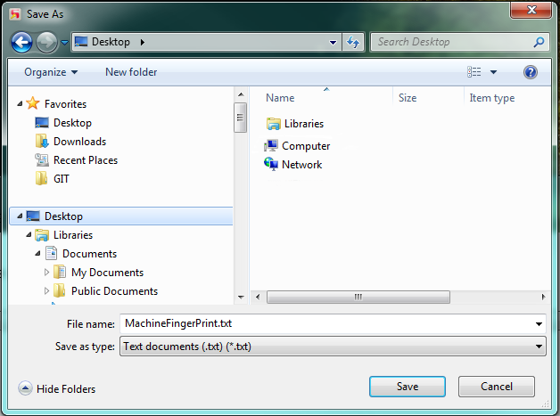

Select a destination path, i.e. a memory stick. Click **Save**:

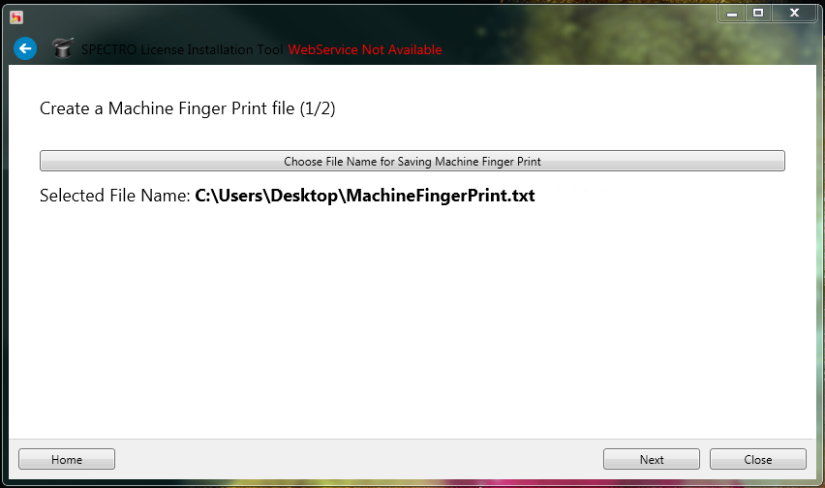

Click **Next**:

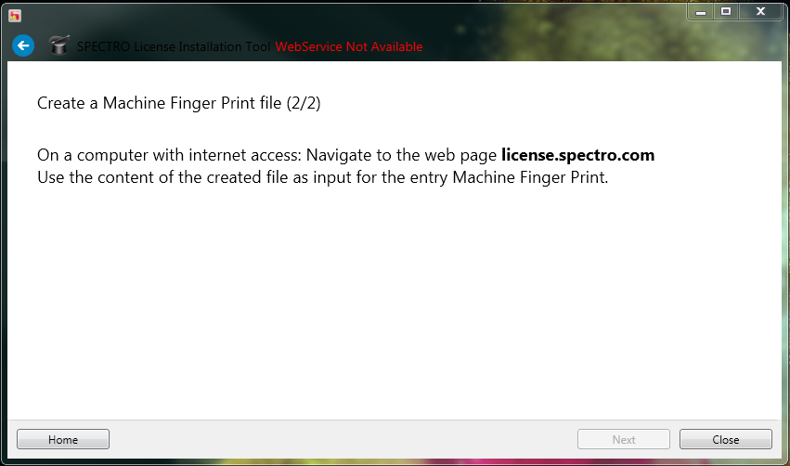

If not already done, copy the file **MachineFingerPrint.txt** to a memory stick.

### Part 2: On a Computer with Internet Access

On a computer with internet access, plug in the memory stick, open a webbrowser and navigate to the webpage **license.spectro.com**:

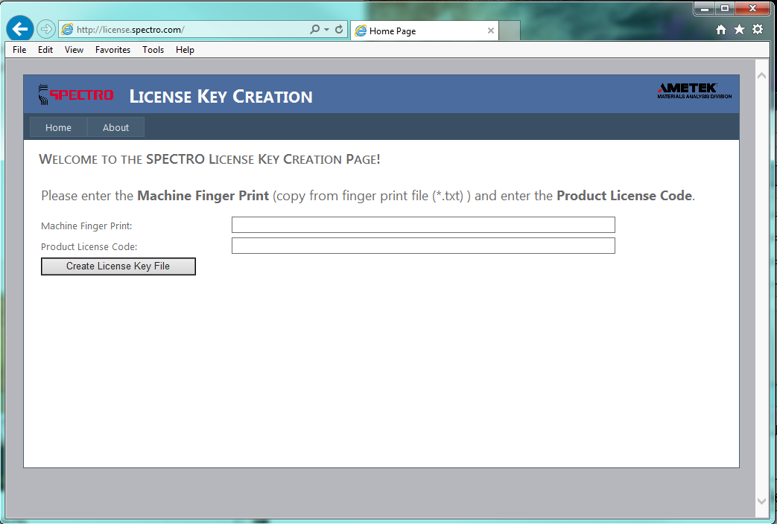

Use the content of the created file **MachineFingerPrint.txt** as input for the entry Machine Finger Print:

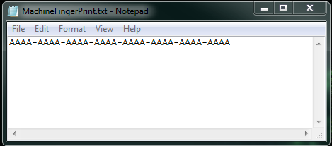

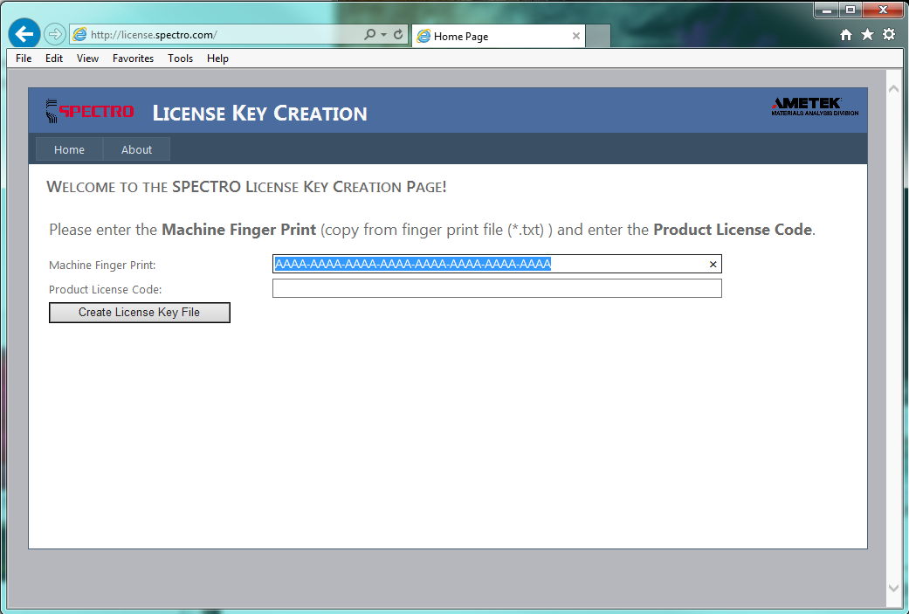

Enter the **Product License Code**:

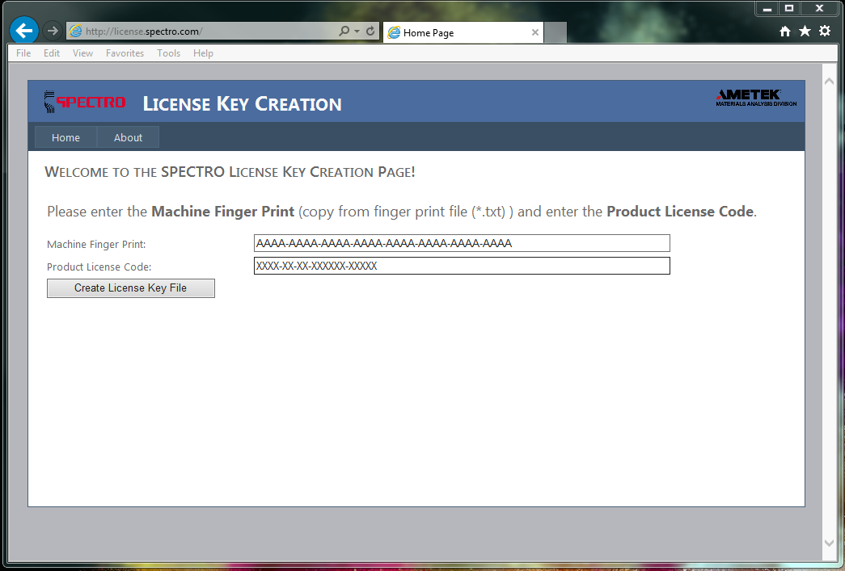

Click **Create License Key File**:

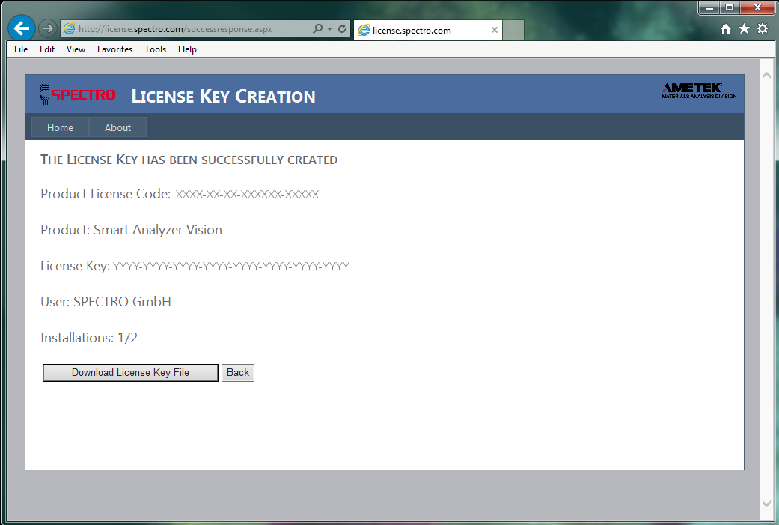

Click **Download License Key File**:

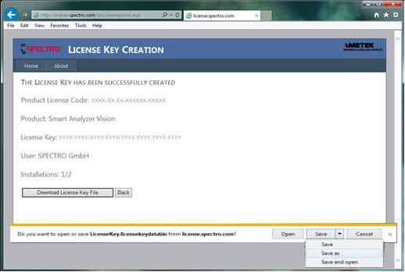

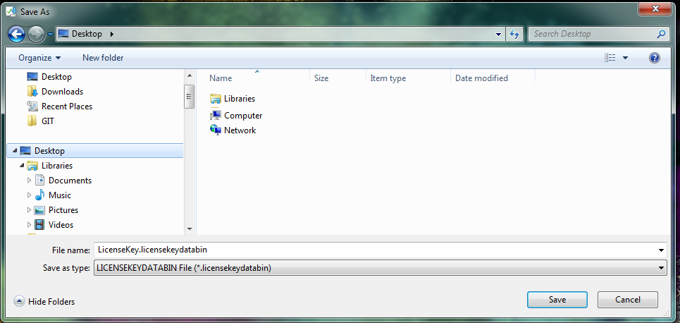

Click **Save**.

Save the file **LicenseKey.licensekeydatabin** to a destination path, i.e. on a memory stick.

### Part 3: On the Instrument Computer

On the instrument PC, insert the memory stick, click **Home** in the program **License Installation Pro** or reopen the program **License Installation Pro** and move to the second page (click **Next** within thewelcomescreen).

Choose **Install a License Key from a file** from the choice list:

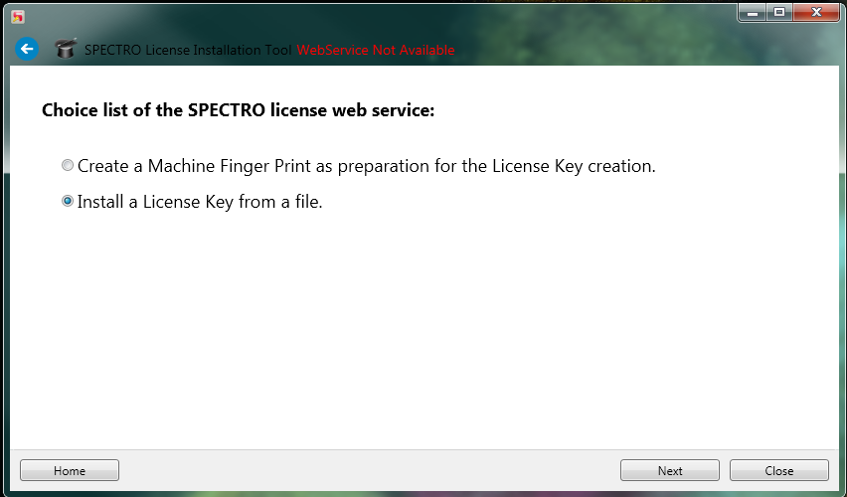

Click **Next**:

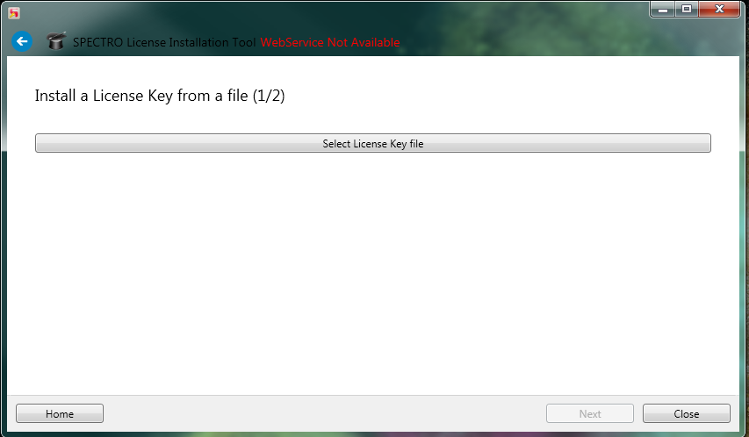

Click **Select License Key File**.

Select the file from the source path, i.e. on the memory stick:

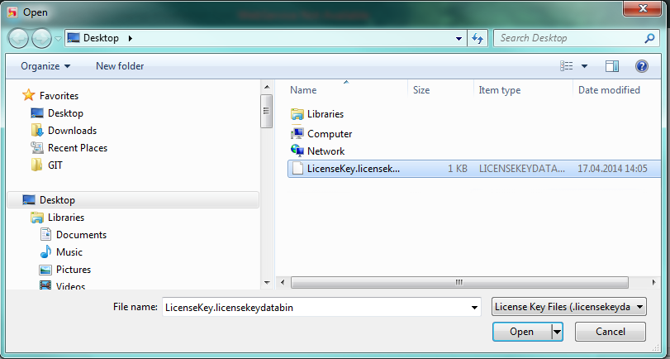

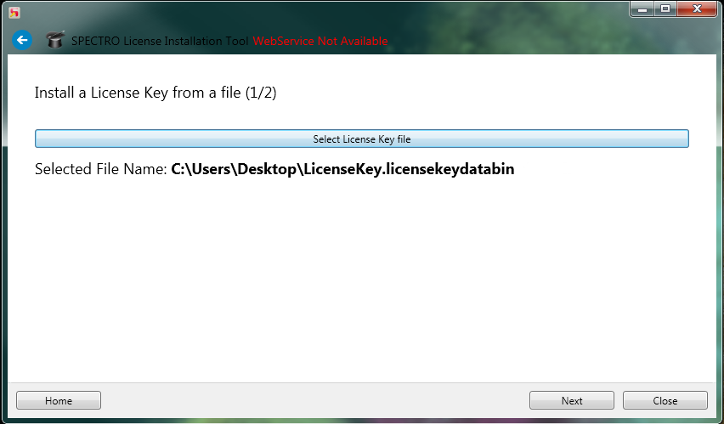

Click **Next**:

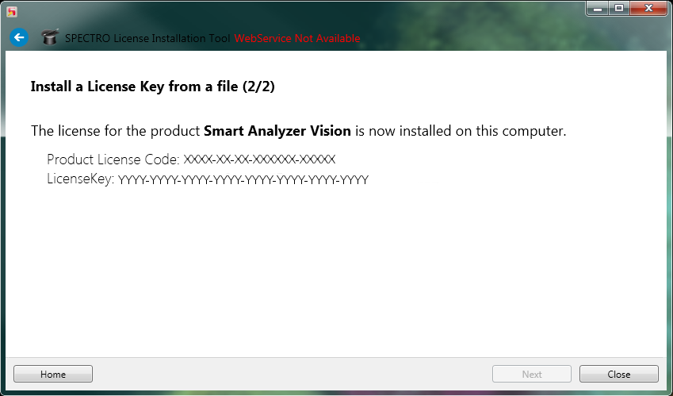

Press **Close**.

The **License Key** is now installed on the computer.

# Remarks

## No Internet Access at the Customer Site

If no internet access is available at the customer site, create the fingerprint file as described in the section **Instrument PC without Internet Access**.

Call your regional center and announce the **Machine Fingerprint** and the **Product License Code**. The regional center can use these entries to create the corresponding **License Key** using the web page **license.spectro.com**.

Enter the **License Key** as a new string value with the name **LicenseKey** in the registry section of the corresponding software, for example ‘Smart Analyzer Vision’.

You can find the registry section here:

**32 bit computers:**

HKEY_LOCAL_MACHINE\SOFTWARE\Spectro\

**64 bit computers:**

HKEY_LOCAL_MACHINE\SOFTWARE\Wow6432Node\Spectro\

Example for the software **Smart Analyzer Vision** on a 64 bit computer:

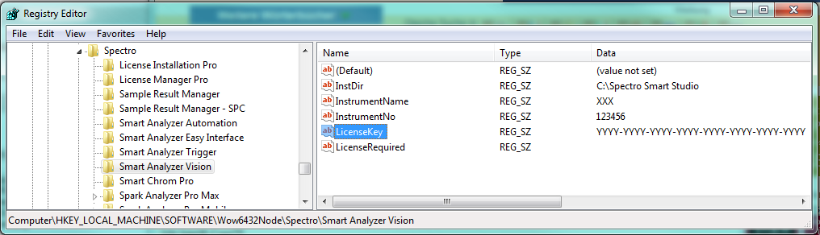

## Remarks on Product License Codes and License Keys

The **Product License Code** is related to the data of a specific customer. It can be used to install as many **License Keys** as given on the **License Certificate**.

Once installed, you can repeat the **License Key** installation of the software with a given **Product License Code** on a given computer as many times as required without decrementing the number of maximum installations. If you use a different computer, the number of installations will be increased.

The **License Key** of a software is unique for a single computer.