**Malachi Noked, Ph.D. 20.11.2018**

Bar-Ilan University , Israel

Chemistry Department

[www.nokedlab.com](http://www.nokedlab.com) , [ORCID 0000-0001-8995-0632](https://orcid.org/0000-0001-8995-0632)

**Personal Statement:**

My eleven years of research experience have trained me as a material scientist with a strong background in the field of nanomaterials, thin films, electrochemical energy storage and electrochemical desalination systems.

With over 45 publications in peer reviewed journals, I have demonstrated a record of success with diverse synthesis and fabrication techniques for electrode materials and surface modification, including physical and chemical vapor deposition (PVD, CVD), atomic layer deposition (ALD), and more. Using this arsenal of synthesis and fabrication techniques, I demonstrated original research contributions and mechanistic understanding of diverse electrochemical systems which involved non-faradaic electrochemistry (supercapacitors and water desalination), Faradacic electrochemistry of 2 phase (pseudo-capacitors, Li ion and Mg-ion batteries), and 3 phase (Metal air batteries) systems.

As a strong believer in education and mentoring, I always balanced my time between acquiring new skills and expertise, and educating, supervising and training younger students in my research team. During my Ph.D., I was nominated by my advisor (Prof. Doron Aurbach) to lead the team that worked on supercapacitors, and to mentor 5 graduates and 5 undergraduate students in works that ended in mutual publications in peer journals. I continued to do so in my postdoctoral studies and was highly involved in mentoring and advising over 10 graduate students in 4 different research groups. My contribution to the publications during my postdoc, has lead my advisors to put me as last and only corresponding author on a major part of our papers.

From an early stage in my career, encouraged by my advisers to pursue future academic position, I was deeply involved in the writing of proposals and grants to support my research, and took care of annual reports and accomplishment presentations for various funding sources. I was also able to find funding sources to support my own position, during my Ph.D. I was dominantly supported by the Eshkol scholarship, and the 1st year of postdoctoral studies was funded by *Fulbright Ilan Ramon* (one out of all Fulbright scholars of my year).

My research group today is composed of 5 postdoctoral fellows (2 of them are highly experienced chief scientists in my group), 5 PhD students and 2 MSc students. Our lab is equipped with 2 ALD reactors, with unique setup for coating of 1D, 2D and 3D structures.

I strongly believe that with my experience, and our current manpower and equipment we are on a perfect position to tackle the challenging proposal presented here.

Educ**a**tion:

**2004-2007 : B. Sc., Biophysics -** Bar-Ilan Unversity, Israel.

**2007-2009 : MSc in Chemistry -** Bar-Ilan University, Israel

**2009-2013:** **Ph.D. in Chemistry -** Bar-Ilan University, Israel [(Mentor: Prof. Doron Aurbach](https://ch.biu.ac.il/aurbach/))

Academic and Professional Experience

**2016 –Today: Senior Lecturer -** Bar Ilan Institute for Nanotechnology and Advanced materials (BINA), Bar-Ilan University, Israel

**2013-2016: Fulbright Fellow and Research Associate**  University of Maryland, College Park,

MD, United States, Mentors- [Professor Gary Rubloff](http://rubloffgroup.umd.edu/), and [Professor Sang-Bok Lee](http://www2.chem.umd.edu/Groups/slee/)

**2007-2013**: PhD student and researcher at the Laboratory of Electrochemistry at Bar-Ilan University, Mentor- [Prof. Doron Aurbach](https://research.biu.ac.il/labs/prof-aurbachs-lab/)

Supervision of Postocs and PhD students (currently in my group):

**Postdocs**: Dr. Sivan Okashy, Dr. Rosy Sharma, Dr. Arka Saha, Dr. Ayan Mukherjee, Dr. Ortal Lidor

**Phd:** Reut Yemini, Tali Sharabani, Sarah Targin, Eliran Evenstein, Ananya Maddegalla.

Teaching experience

2015 **Instructor and Lecturer**- Advanced Materials Fabrication Course and Laboratory (Department of Materials Science and Engineering- University of Maryland College Park)

2017-2018 **Lecturer** – Inorganic Chemistry, chemistry department. Bar Ilan University, Introduction to Nano materials. Bar-Ilan University

2017-2018 **Instructor** – Laboratory for Analytical Chemistry Bar-Ilan University

Honors and Fellowship:

2009-2012 - Doctoral Fellowship of **excellence in nanotechnology**- BINA center.

2010 **Schechter** Award for Excellence – Chemistry department BIU

2011-2013 **Eshkol** fellowship for Ph.D. students - The Israeli Ministry of Science.

2013 **Lindau** Nobel Laureate Meeting participant (Chemistry).

2013 **Excellent PhD student** of Chemistry- Israel Chemical Society (ICS).

2013-2014 **Fulbright** fellowship for postdoctoral studies.

2013-2014 Fulbright **Ilan-Ramon** Fellowship for postdoc (1 chosen from all 2013 Fulbrighters).

2017- 2020 **Yigal Alon** Fellowship for young scientists.

Organisation of **scientific** meetings

Thin Film Deposition and Characterization – GSD Workshop, 2017.

Reviewing and Professional activities:

2018-2019 **Proposal reviewer**: Israel Ministry of Science 2018

2018-2019 **Fulbright Alumni MA Committee.**

2015- **Manuscripts Referee** for: Nature Energy, JACS, *Nature Communication*, *Advanced Energy Materials*, Nano Letters, *ACS Nano, Angewandte Chemie, ACS Applied Materials & Interfaces*, CARBON, *Journal of Solid State Electrochemistry*, *and Journal of the Electrochemical Society*.

Early achievements track record

The **versatility** of my acquired experience in ***fabrication*** and ***applied electrochemistry*** devices equipped me with an unusual ***high degree of freedom*** in choice of research field of interest, and **full flexibility** to adjust my research studies to **any electrochemical system** in terms of electrolyte medium (aqueous, organic, solid electrolyte), application (batteries, supercapacitors, desalination, corrosion, sensitized solar cell etc.), and electrode material. Indeed, my research contribution covers many aspects of modern applied electrochemistry.

With over 45 papers in peer review journals, **h-index of 26 and i-10 of 36** I showed original research contributions and mechanistic understanding of diverse electrochemical systems.

In my PhD, I managed to gain mechanistic understanding of selective water desalination by electrochemical means, and to fabricate novel porous carbon electrodes for supercapacitors and separation processes.

In my postdoc I lead the 1st reported ALD protection on lithium metal anode (over 230 citations in three years), and the 1st reported ALD of lithium ion conducting film on metallic anode. I also demonstrated mechanistic understanding of degradation processes in next generation rechargeable batteries, and mitigation strategies to overcome the degradation pathways. The strategies include ALD of solid electrolyte, synthesis of scientifically informed electrode architectures and manipulation of the electrolyte solutions.

Since my new appointment as faculty at Bar Ilan, I managed to propose strategies for stabilization of metallic anode in rechargeable batteries (ACS Energy Highly cited paper of 2017) and was invited by Nature Energy journal to farther write a point view on that subject. I established a new lab with state of the art synthesis capabilities for electrode stabilization, and *in-operando* electrochemical mass spec analysis (Scheme 1 at the bottom of next page)

Selected Conferences:

Invited talk: **NANOIL 2018** Electrode Material’s Modifications Using Atomic Layer Techniques

Invited talk: **IMEC 2018** “SUPPRESSION OF ELECTRODE MATERIAL DEGRADATION USING ATOMIC LAYER MODIFICATIONS TECHNIQUES”

Invited talk: **GIBS 2017**(German Israel Battery conference) “Suppression of Electrode Material Degradation Using Surface Modifications Techniques”

Oral presentation- ECS 2015 Phoenix, “Interface Engineering of Lithium Metal Anodes”

Invited oral presentation- ***Gordon electrodeposition***; Electrochemical Materials Synthesis and Applications (**2014**) - "Template Synthesized Nanowires and Nanotubes for Energy Storage Materials".

Oral presentation- ***AVS 61st International Symposium & Exhibition***- Energy Frontiers Focus Topic - “Controlled Cathode/Catalyst Architectures for Li-O2 Batteries”.

Invited talk- Excellent Graduate Student oral presentation- ***78th Annual Meeting of the Israel Chemical Society.*** “Superb composite CNT/Activated Carbon Electrodes for EDL Super Capacitors”

Invited talk : ***The Israeli Cells and Batteries Know How Center IFCBC-*** “News in R&D of supercapacitors”. 2013

## GRANTS received within the past five years

2016 - 2017 Advanced Research Projects Agency-Energy (ARPA-E) Funding Opportunity Announcement (FOA) DE-FOA-0001002 IDEAS - As Co-PI at UMD

2016 – 2021 Researcher in Israel National Research Center for Electrochemical Propulsion (INREP2), funded by the Israeli Council For Higher Education

2017- 2020 Alon Fellowship for Outstanding Young Researchers

2017-2020 Indivdual ISF grant “Atomic Layer Deposition of LixVyOzPO4 to Mitigate Dissolution of Oxide Cathode Materials”

2017–2018 ISF Equipment for new faculty “Laboratory for thin film deposition for electrochemical applications”

2017-2019 Israel Ministry of Energy Grant #: 217-11-030 “Design, Function and Utilization of Thin Coatings for Next Generation Batteries”

2018-2019 Ministry of Defense Israel (Administration for the Development of Weapons and Technological Infrastructure). Grant # “Photo-thermal printing of micro-batteries”.

2018-2022 Horizon 2020 Framework Programme Call for proposals: H2020-FETPROACT-2018-2020 (H2020-FETPROACT-2018-01) Proposal: 824066 — E-MAGIC – Co PI

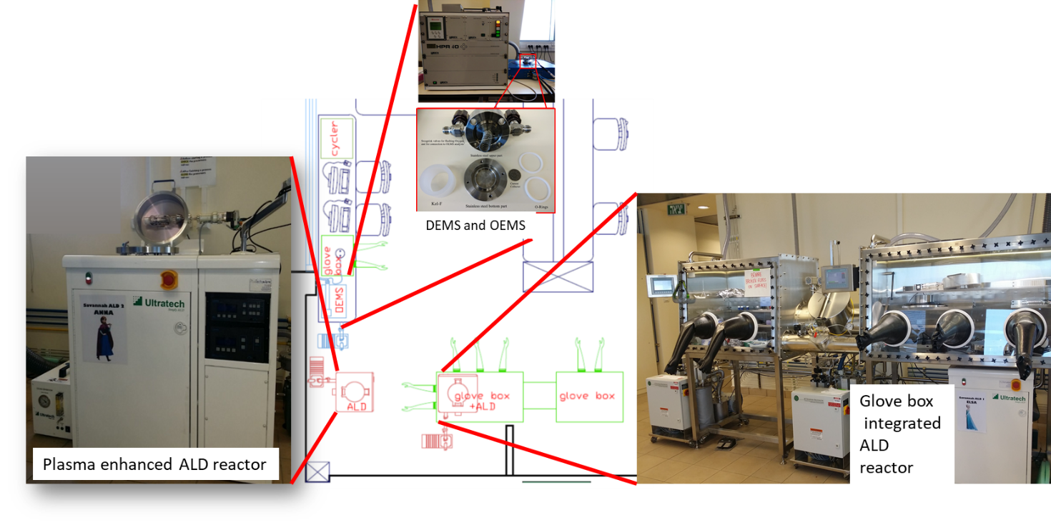

Scheme 1: Scheme and part of the equipment currently installed at Noked Lab .