**Daniel Filiuk**

**PERSONAL DETAILS**

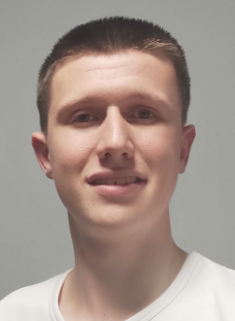Gmail: [danif99@gmail.com](mailto:danif99@gmail.com)

Phone: 0534252513

Birthday: 9.6.1999

Linkedin: <https://www.linkedin.com/in/daniel-filiuk-710a17a5/>

Github: <https://github.com/danif99/ReverseEngineering>

**SKILLS**

**Malware analysis & Reverse engineering**: Static & dynamic analysis, packers & unpackers, monitor malware, anti-debugging, PE format, anti-reverse engineering, detect and defend against malware

**RE Tools:** IDA-PRO, x64dbg, OllyDbg, WinDbg, Ghidra

**Penetration testing** : Vulnerability scanning, DOS, brute force, exploiting, privilege escalation ,SIEM

**Network security**: TCP/IP, ACL, HTTP, DNS, Firewall, ARP, WAN / Lan

* **Software and programming language**: VirtualBox, Vmware, Assembly X86 64, C, Python, Visual Studio 2019, active directory
* **Personal skills**: Self-learning, can work well under pressure, flexible, team player, highly motivated, team leader

**Military service**

* Guide new soldiers
* Responsible for soldiers under my command
* Graduated from Marom Technician, which I graduated with honors
* Works in collaboration with representatives of Elbit

**Education**

* 2020 – 2021 course: C programming and reverse engineering at Technion
* 2019 – 2020 cyber security and system administrator at Technion, MCSA, CCNA, CCSA, Linux, PT
* 2018: ORT Kiryat Motzkin: 12 years of study, Technological major, matriculation and certificate Technology (electronics)

**Languages**

Hebrew – native | English – advanced | Russian – elementary